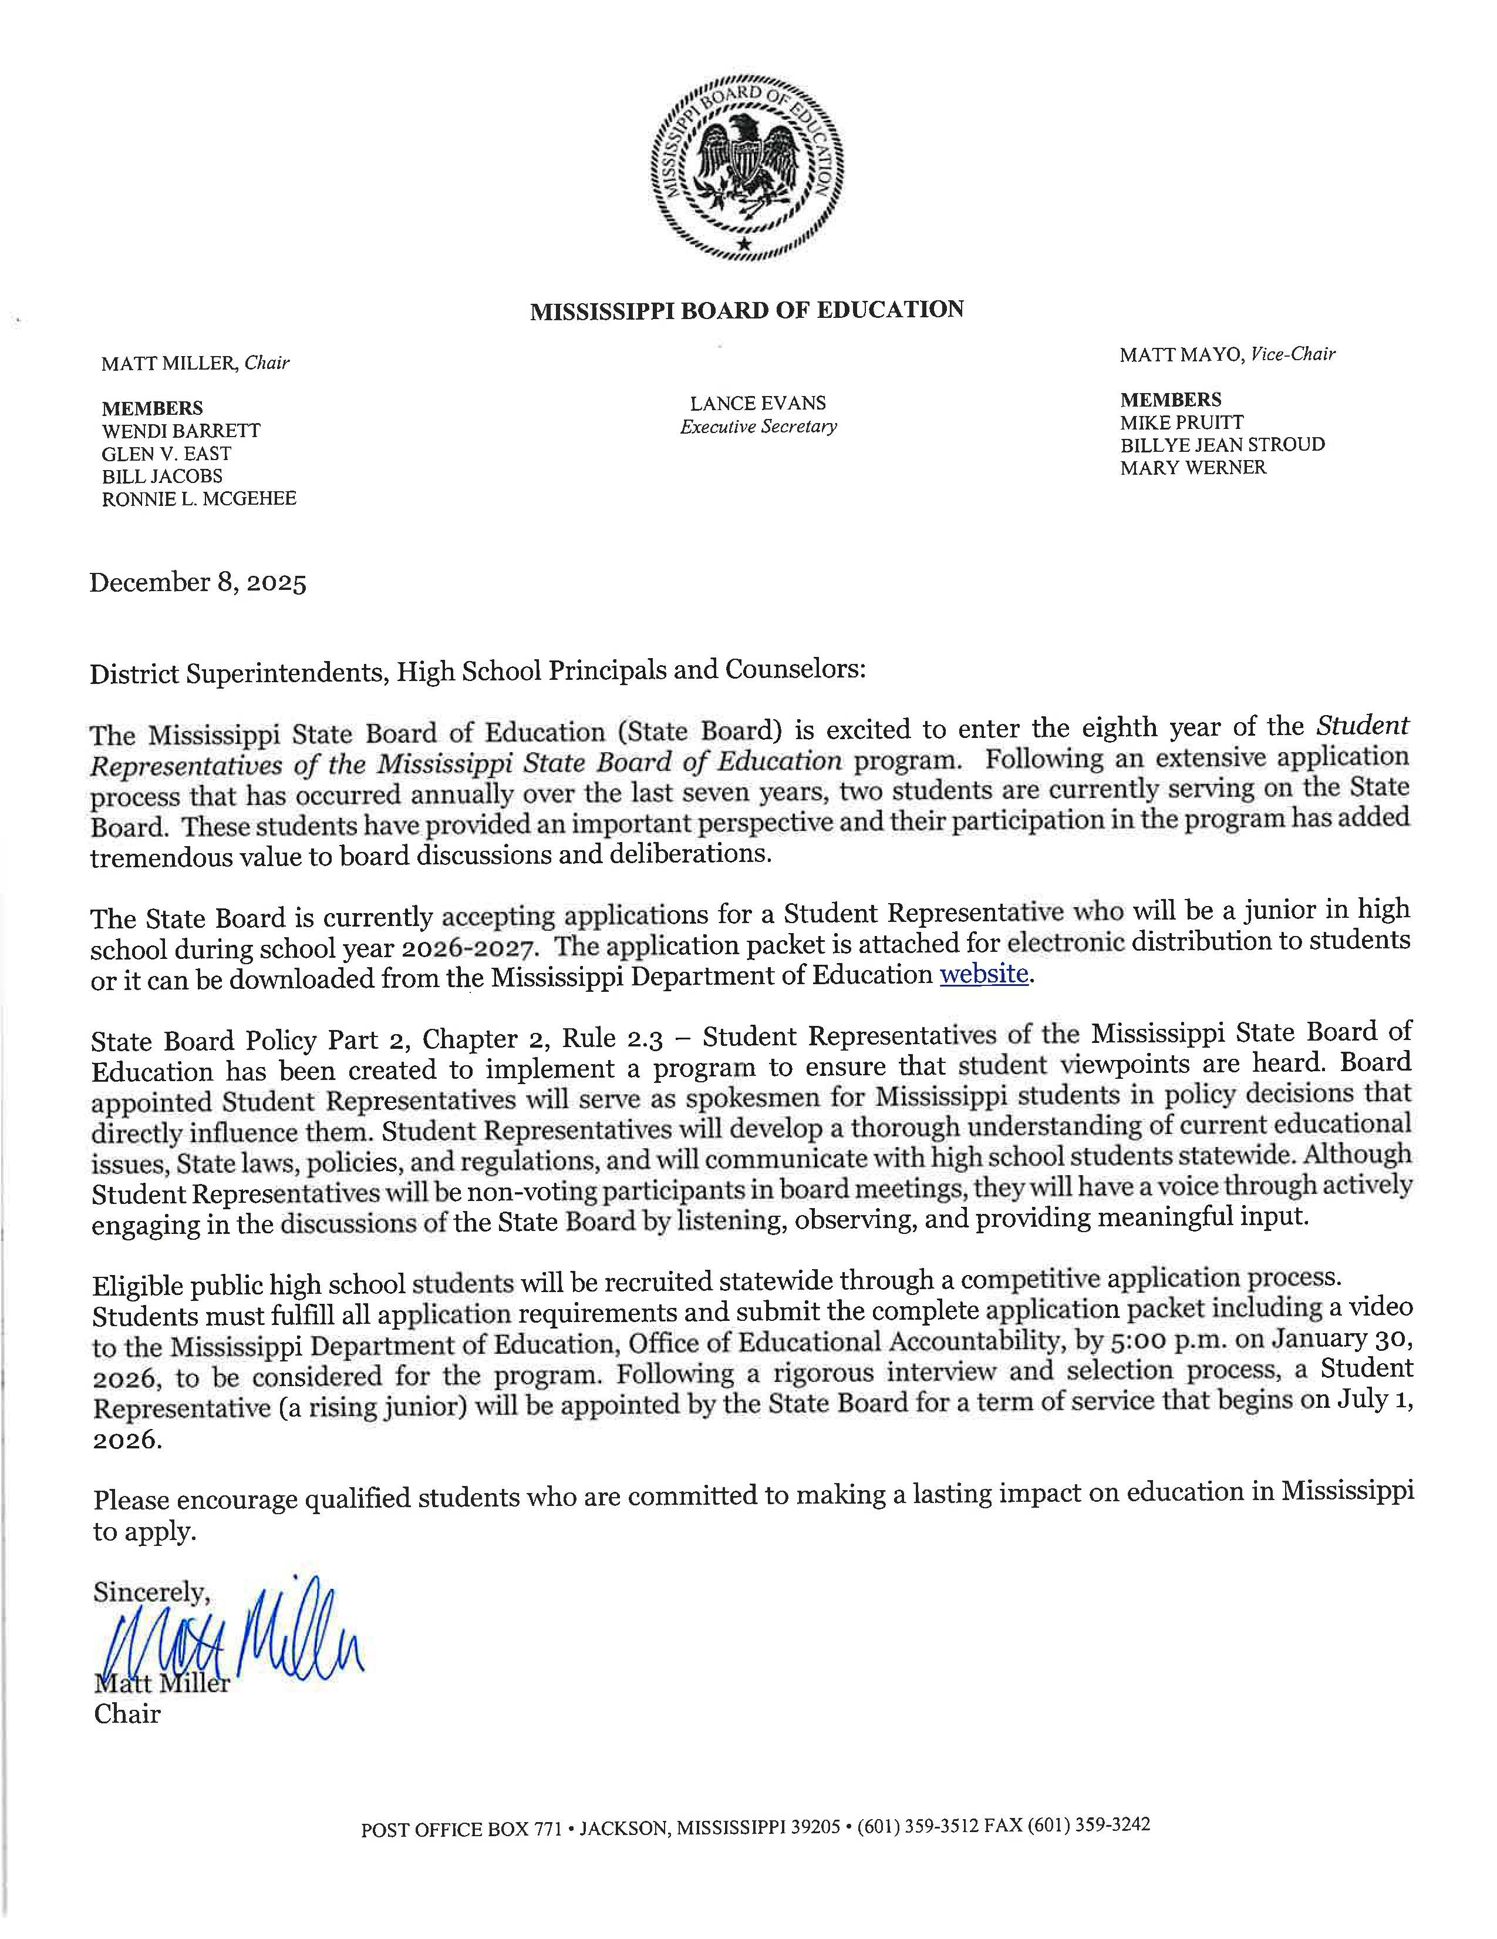

 | 2026 - 2028  MISSISSIPPI STATE BOARD OF EDUCATION  STUDENT REPRESENTATIVE APPLICATION PACKET

Personal Information
Name of Student | E-mail Address
Mailing Address | Telephone Number
Name of School District of Enrollment | Name of High School
Present Grade Level

Instructions for Completing the Application Packet
The application packet may be obtained from the high school principal or counselor or downloaded from the Mississippi Department of Education website and shall be completed by computer.
The applicant is responsible for compiling all documents associated with the application packet and submitting one complete packet to the Mississippi Department of Education by the deadline. The application packet must be postmarked by January 30, 2026.

Mail: Sherry Bombich, Admin Support Specialist
Office of Educational Accountability
Mississippi Department of Education
Post Office Box 771
Jackson, MS 39205-0771

Physical Address: Sherry Bombich, Admin Support Specialist
Office of Educational Accountability
Mississippi Department of Education
359 North West Street
Jackson, MS 39201

It is recommended that applicants submit the application packet via certified mail.
The link to the applicant’s video uploaded on YouTube for the video requirement component of the application shall be submitted electronically by 5:00 p.m. on January 30, 2026, to the following email address: sbestudentrep@mdek12.org.
Students must fulfill all application requirements and submit the complete application packet including the video to the Mississippi Department of Education, Office of Educational Accountability, by the deadline to be considered for the program.
Contact Sherry Bombich in the Office of Educational Accountability by phone (601) 359-9714
or via email sbombich@mdek12.org if you have any questions.

The Mississippi State Board of Education and the Mississippi Department of Education do not discriminate on the basis of race, color, religion, national origin, sex, age, or disability in the provision of educational programs and services or employment opportunities and benefits. The following office has been designated to handle inquiries and complaints regarding the non-discrimination policies of the above-mentioned entities:
Director, Office of Human Resources
Mississippi Department of Education
359 North West Street
Jackson, Mississippi 39201
601-359-3511
Any individual with a disability who requires reasonable accommodation during the application process, or to participate in interviews or meetings of the Mississippi State Board of Education, may request assistance by contacting the Office of Educational Accountability at 601-359-9714.

APPLICATION PACKET CHECKLIST

A complete application packet includes the following:
Personal Information section completed
Student Acknowledgement Form signed by the applicant (all 4 pages enclosed)
Parent or Guardian Consent Form signed by the parent or guardian
School District Personnel Verification Form signed by the Superintendent, Principal
and Counselor
Description of extracurricular activities, community and volunteer service, academic achievements and honors, and work experience (from 7th grade to present)
Three recommendation letters are required from the following:
1) teacher who has instructed you;
2) an administrator; and
3) other adult who knows you but is not a family member
Responses to the three essay questions (250 words or less per question)
Video – Uploaded on YouTube and link emailed to sbestudentrep@mdek12.org

NOTE: The student’s name shall be included on every page of the application packet that is submitted to the Mississippi Department of Education and in the subject line of the e-mail submitted with the link to the YouTube video.

STUDENT ACKNOWLEDGEMENT FORM

Purpose: The Mississippi State Board of Education (State Board), in an effort to include student perspectives on state educational policies, laws and regulations, shall incorporate student representation in a non-voting capacity by and through the appointed position of Student Representative of the State Board, in accordance with the Mississippi State Board of Education Policy, Part 2, Chapter 2, Rule 2.3.
The Student Representative shall serve as a link between board level policy and the classroom. The Student Representative shall serve as a trustee on behalf of Mississippi students and shall be charged with providing perspectives on issues of interest to students and ensure student’s voices are represented. The Student Representative shall be responsible for attending State Board meetings as well as standing committee(s) or subcommittee(s) to which he or she may be assigned. Unless invited to attend by an affirmative vote of a majority of the State Board, the Student Representative may not attend Executive Sessions of the State Board. Student Representatives shall be excused from school to attend State Board meetings as official school business.
Term of Service: Through a competitive application process, the State Board shall appoint one rising junior to serve as Student Representative. The junior representative shall be promoted to a senior representative and shall continue to serve for a second year, and a new junior shall be appointed annually. The term of service for rising juniors shall begin on July 1st of Year 1 and shall end on April 30th of Year 2. The junior representative shall attend a board orientation session that will be scheduled prior to the July 2026 board meeting and shall attend the July 2026 board meeting as well.
Eligibility: Students who meet the following criteria are eligible to apply for the Student Representative program:
1. Any student who is a Mississippi resident, enrolled in a Mississippi public high school or charter school, and who will be enrolled in good standing in the eleventh grade may apply. Confirmation of eligibility shall be received from the high school counselor as part of the application process.
2. A student must have an overall grade point average of 3.0 or above. Confirmation of eligibility shall be received from the high school counselor as part of the application process.
Upon appointment, Student Representatives must maintain eligibility throughout the term of service.
Application: The Office of Educational Accountability will prepare and disseminate an application packet to all public high schools and charter schools in Mississippi. The application packet will also be uploaded to the Mississippi Department of Education website. Students shall complete all application requirements and submit the application to the Mississippi Department of Education by the deadline to be considered for the program.

Application requirements will include, but not be limited to, the following:
- Student shall submit at least 3 recommendation letters (from a teacher who has instructed the student, an administrator, and other adult who knows the student but is not a family member).
- Student shall agree to provide his/her own transportation to board meetings, activities, and events. Student Representatives will be reimbursed for approved travel expenses such as mileage, lodging and meals incurred while traveling on official board business upon submission of a claim to the State Superintendent based upon the guidelines established by the Mississippi Department of Finance and Administration (DFA) in accordance with Miss. Code Ann. § 25‐3‐41.
- Student shall have written consent of a parent or guardian, as well as the approval of the principal and district superintendent to apply for the Student Representative position.
- Student shall have written confirmation from his/her counselor that the eligibility requirements have been met.
- Student shall provide responses to the essay questions.
- Student shall have the opportunity to highlight his/her extracurricular activities, community and volunteer service, work experience and academic achievements and honors.
- Student shall upload a video to YouTube, 4 minutes or less, stating how he/she will contribute as a Student Representative of the Mississippi State Board of Education by being the voice of students statewide.
Screening: Immediately following the application deadline, the Office of Educational Accountability shall review the applications received to ensure all application requirements have been met for candidates to be considered for an interview. Applicants who do not meet all eligibility criteria and application requirements shall be automatically disqualified. Applications received after the deadline for submission shall be disqualified. All qualified applications shall be screened as follows:
1. The Internal Accountability Subcommittee Chair shall work with the State Superintendent to appoint the internal Ad-Hoc Screening Committee(s) of five members composed of one Internal Accountability Subcommittee member and four Mississippi Department of Education staff.
2. The Screening Committee(s) review all qualified applications and rate each application holistically, selecting at least the top 10 semifinalists who reflect the best cross-section of the many outstanding students who apply.
Interview and Appointment: The interview and appointment process shall be conducted as follows:
1. The semifinalists shall be interviewed by the Internal Accountability Subcommittee of the State Board in May.
2. The Internal Accountability Subcommittee shall recommend no more than four finalists to the State Board for an interview to be held on June 17th, 2026. One junior representative shall be appointed by the State Board.
3. The Internal Accountability Subcommittee shall document the next highest scoring candidates in rank order should an alternate(s) be needed to fulfill the duties of a Student Representative(s) during his/her term.
Duties and Responsibilities: Upon appointment by the State Board, the Student Representative shall, at minimum, fulfill the following duties and responsibilities:
1. Attending monthly State Board meetings is required in addition to attendance of special-called meetings or other meetings or events as requested by the Board Chair. When a school activity prevents a Student Representative from attending a State Board meeting, he/she should provide notice to the State Board Chair. Additional absences should be limited to no more than two absences per fiscal year. Any other circumstances that would prevent attendance at the meetings must be reviewed and approved by the Board Chair.
2. Preparing for State Board meetings by reviewing the packet of board meeting materials provided prior to the meetings. A report shall be given by each of the Student Representatives at each monthly meeting and shall be submitted for Board Chair review at least ten days prior to the meeting.
3. Attending a one-day orientation session.
4. Participating actively in the discussions of the State Board by listening, observing, and providing meaningful input.
5. Working harmoniously with other State Board members and Mississippi Department of Education staff.
6. Accepting the will of the majority vote of the State Board in all cases and giving support to the resulting policy.
7. Developing a thorough understanding of current educational issues, State laws, policies, and regulations that directly impact Mississippi students and sharing this info with high school students statewide.
8. Serving as a spokesman for student viewpoints in policy decisions directly influencing students and communicating with students frequently. It is important that the Student Representative elicit information from students statewide and attempt to formulate objective opinions.
9. Participating in the selection process of the incoming Student Representative.
10. Serving as a mentor for the incoming Student Representative.
11. Preparing and presenting a report to the State Board at the end of the term of service that documents lessons learned and ways to strengthen the Student Representative program in the future.
12. During their senior year, Student Representatives may be given the opportunity to complete a capstone project that shall be presented to the State Board and other organizations in their community and to receive academic credit for the project.
Conflict of Interest: In order to be considered for the Student Representative program, the student cannot be a relative of a current Mississippi State Board of Education member or a relative of an employee of the Mississippi Department of Education. A relative is defined as a spouse, child, child’s spouse, parent, parent’s spouse, sibling, and sibling’s spouse.
Statement of Understanding: I have read the information included in the Mississippi State Board of Education Student Representative application packet and understand the purpose, term of service, eligibility requirements, application submission requirements, screening process, interview and appointment process, duties and responsibilities, and conflict of interest requirements. I understand and agree that failure to submit all required documents in the application packet and/or failure to submit the application packet by the deadline shall result in automatic disqualification of my application. I agree for my application packet to be reviewed. I agree that any and all information contained in my student file shall be released to the State Board of Education upon request including my transcript and disciplinary report. If I am selected for interview(s), I agree to attend the interview(s) at my own expense. I certify that the information I have provided is true, and if I am appointed by the Mississippi State Board of Education to serve as a Student Representative, I will fulfill the term of service and perform the duties and responsibilities of the position to the best of my ability.
Signature of Student Applicant | Date
Typed or Printed Name of Student Applicant

PARENT OR GUARDIAN CONSENT FORM
The undersigned parent/guardian of ___________________, states as follows:
My child has my consent to file the foregoing application and to serve, if appointed, as the Student Representative of the Mississippi State Board of Education for a term beginning July 1, 2026. The end of the term is April 30, 2028. I make this consent based on my assessment of my child’s interest in serving on the Mississippi State Board of Education and his/her ability to participate in board activities without harmful effect to his/her academic achievement.
I acknowledge that my child shall be required to attend board meetings in person and fulfill the duties and responsibilities of the Student Representative of the Board. I shall supervise my child while he/she is participating in official board activities. I acknowledge that the Mississippi State Board of Education typically meets on the third Thursday of each month at 10 a.m. in the 4th floor Board Room of the Central High School building located at 359 North West Street in Jackson, Mississippi. Additional meetings, activities, or events may be held during the year in Jackson or in other locations as the State Board deems necessary. Transportation to/from board meetings, activities, and events is the responsibility of the Student Representative and his/her parents (guardians). Approved travel expenses such as mileage, lodging and meals incurred while traveling on official board business shall be reimbursed upon submission of a claim to the State Superintendent based upon the guidelines established by the Mississippi Department of Finance and Administration (DFA) in accordance with § 25‐3‐41, Mississippi Code of 1972, Annotated.
I have read the Student Acknowledgement Form and am aware of the terms and conditions of the agreement for which my child signed.

I acknowledge that the State Board of Education, the Mississippi Department of Education, nor any employee, member, or agent thereof, acts in loco parentis or as chaperone(s) at meetings of the Mississippi State Board of Education.

If my child is chosen as a semifinalist, I consent for him/her to participate in an interview to be conducted by the Internal Accountability Subcommittee of the Mississippi State Board of Education. I understand this interview is open to the public and information in his/her education record may be discussed.
If my child is chosen as a finalist and progresses to the next stage, I consent for him/her to participate in an interview to be conducted by the Mississippi State Board of Education. I understand this interview is also open to the public and information in his/her education record may be discussed.
The Mississippi Department of Education has my permission to photograph my child and to use photographs for publicity that might include but is not limited to website, PowerPoint presentations, promotional videos, flyers or news publication.

I hereby fully and completely release the Mississippi State Board of Education, the Mississippi Department of Education, and its agents, servants, or employees from any and all claims, charges, demands, damages, costs, expenses, actions and causes of action of every kind and whatsoever nature which they have now or hereafter have which are in any manner whatsoever related to participation in the Student Representative program.

I may withdraw this consent, in writing, at any time that I determine that participation as a Student Representative of the Mississippi State Board of Education is contrary to my child’s best interest.
Signature of Parent or Guardian | Date
Typed or Printed Name of Parent or Guardian | Telephone Number
E-mail address

Name of Student

SCHOOL DISTRICT PERSONNEL VERIFICATION FORM
The undersigned Superintendent and Principal hereby state that the student listed below is hereby approved to submit his/her application for consideration as the Student Representative of the Mississippi State Board of Education for the term beginning July 1, 2026. The end of the term is April 30, 2028.
The undersigned Principal hereby agrees to provide the student with access to resources currently available at the school that are necessary to fulfill the video submission requirement if the student does not have the resources to do so. These resources include use of a video recording device, the ability to upload a video to YouTube, and the ability to e-mail the link.
On behalf of the district and school named below, the undersigned confirms that, if appointed to the State Board, the student’s absences from school for participation in official State Board activities shall be deemed school-related and shall be excused as official school business and shall not be marked as unexcused absences.
Signature of Superintendent | Typed or Printed Name of Superintendent | Date
Signature of Principal | Typed or Printed Name of Principal | Date
Name of School District | Name of High School
Name of Student

COUNSELOR VERIFICATION
Current Grade Level of Student: ____ (must be 10th grade)
Current Cumulative Grade Point Average (GPA): ____ (must be 3.0 or higher)
Is student currently in good standing? ____ Yes ____ No
The undersigned High School Counselor hereby states that the student listed above is in good standing and is enrolled as a full-time student in the school listed above. The undersigned further verifies that the student has an overall grade point average of 3.0 or above and is therefore eligible to submit his/her application for consideration as the Student Representative of the Mississippi State Board of Education for the term beginning July 1, 2026.
Signature of High School Counselor | Typed or Printed Name of High School Counselor | Date

RECOMMENDATION LETTERS

Instructions:
I. Three recommendation letters are required from the following individuals:
- teacher who has instructed you;
- an administrator; and
- other adult who knows you but is not a family member
II. Recommendation letters shall be prepared and submitted as follows:
- Letter must be typed.
- Letter must include the date of recommendation.
- Letter must include the name of the student.
- Letter must include the name, phone number, and/or email address of the person making the recommendation.
- Letter must designate your relationship with the student (teacher, administrator, or other).
- Letter should be addressed to Mrs. Sherry Bombich, Office of Educational Accountability, Mississippi Department of Education, Post Office Box 771, Jackson, MS 39205-0771 and should be included in the application packet when mailed.
- Letter should include your comments on how the student has excelled in the following areas:
  - Leadership Positions
  - Attitude/Character
  - School/Community Involvement
  - Academics
  - Work Ethic (in and out of class)
  - Honors/Awards
  - Other Areas of Interest
- Letter should include your perspective regarding the student’s ability to serve as a Student Representative of the Mississippi State Board of Education. (Please refer to the Student Acknowledgement Form in the Application Packet that outlines the duties and responsibilities of the Student Representative of the Mississippi State Board of Education.)
- Letter must be signed by the person making the recommendation.
- Letter must be provided to the student to submit with the application packet and should not be sent in separately from the application packet.

ACTIVITIES, SERVICE, ACHIEVEMENTS, AND WORK EXPERIENCE
Instructions:
Provide highlights for each of the four areas: Extracurricular Activities, Community and Volunteer Service, Academic Achievements and Honors, and Work Experience. The list should be presented in reverse chronological order with the most recent entry first. Specify leadership positions held in these areas. Entries should reflect accomplishments acquired since the beginning of 7th grade.

I. Extracurricular Activities | Leadership Position(s) Held | Dates of Activity  (month/year – month/year)
II. Community and Volunteer Service | Leadership Position(s) Held | Dates of Activity  (month/year – month/year)
III. Academic Achievements and Honors* | Leadership Position(s) Held | Year(s)
* If known, please include ACT score, class rank, and class size in this section.
IV. Work Experience | Leadership Position(s) Held | Start Date/End Date  (month/year – month/year)

ESSAY QUESTIONS
Instructions:
Provide responses to the following three (3) questions. Responses should be limited to 250 words per question. Include the question # and question before each response.

- Why are you interested in serving as a Student Representative of the Mississippi State Board of Education and what qualities and experience do you possess that make you the best candidate for the position?

- How has public education impacted your life and what changes would you recommend to the State Board of Education that would enhance the educational experience for students?

- Keeping in mind the areas of authority of the Board, what do you consider to be one of the most difficult issues affecting public education (Pre-K to 12th grade)?

VIDEO

Instructions:
Each applicant must produce a video, 4 minutes or less, stating how he/she will contribute as a Student Representative of the Mississippi State Board of Education by being the voice of students statewide as prescribed in the Mississippi State Board of Education Policy -Part 2, Chapter 2, Rule 2.3.
The Student Representative will serve as a link between board level policy and the classroom. The Student Representative will serve as a trustee on behalf of Mississippi students and will be charged with providing perspectives on issues of interest to students and ensure student’s voices are represented.
It is important that the Student Representative elicit information from students statewide and attempt to formulate objective opinions.
The applicant shall begin the video with an introduction that includes the applicant’s name and the name of the high school he/she attends.
The applicant shall upload the video to YouTube and shall e-mail the YouTube link to sbestudentrep@mdek12.org by 5:00 p.m. on January 30, 2026. Please include the name of the applicant in the subject line of the e-mail. The applicant will receive an e-mail from the Mississippi Department of Education confirming receipt of the YouTube link if it is received by the deadline. If confirmation is not received and the applicant would like to inquire about the status, please contact Sherry Bombich in the Office of Educational Accountability by phone (601) 359-9714 or via email sbombich@mdek12.org.
Prior to publishing the video, the applicant will have the option to select a setting of public, private, or unlisted. In an effort to control privacy, it is recommended that the applicant select the setting of unlisted. By selecting the unlisted setting, YouTube allows the link to be copied. The applicant shall copy the link of the unlisted video and paste the link of the unlisted video into the body of the e-mail that shall be sent to sbestudentrep@mdek12.org.
Instructions on how to upload a video to YouTube as well as how to choose the privacy settings for the video can be found here.


Mississippi State Board of Education
2026 - 2028 Student Representative Program
Application and Recruitment Timeline
Date | Action | Responsible Person(s)
December 8, 2025 | - Application released to district superintendents, high school principals, and counselors  - Application posted on SBE web site  - Press Release | Educational Accountability  Communications
January 30, 2026 | Application deadline for submission. | Educational Accountability
February 2026 | Application packets reviewed to ensure they are complete, and all eligibility requirements have been met for an applicant to be considered for interview. Application documents prepared for the Ad-Hoc Screening Committee. | Educational Accountability
March 2026 | - Ad-Hoc Screening Committee will review all qualified applications. The Committee will rate each application holistically, selecting at least 10 semifinalists who reflect the best cross-section of the many outstanding students who apply.  - Press Release | Ad-Hoc Screening Committee  Communications
May 6 - 7, 2026 | Semifinalists will be interviewed by the Internal Accountability Subcommittee and up to the top 4 highest scoring finalists will be recommended to the SBE for interview. | Internal Accountability Subcommittee
June 17, 2026  SBE Work Session  8:30 a.m. | - The State Board of Education will interview the finalists.  - The State Board of Education will appoint a Student Representative and a Student Representative Alternate.  - Final Press Release | State Board of Education  Communications
July 1, 2026 | The term of office will begin for the new Student Representative. The Student Representative will attend an orientation session and the State Board of Education meeting in July. | Student Representative  MS School Boards Association  State Board of Education
- The project timeline will be revised as needed to accommodate board member and committee member schedules.

