Your Ticket to STEM Success: Free Virtual Resource Fair Presented by the Mississippi Statewide Afterschool Network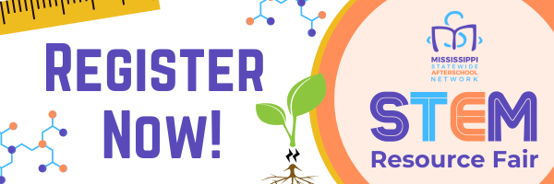

**Register now for free** through [Eventbrite](https://www.eventbrite.com/e/msan-stem-resource-fair-tickets-943724163377?aff=edupdate) and get ready to spark your student's curiosity!

Calling all Mississippi educators and STEM enthusiasts! Are you looking for innovative ways to engage your students in the exciting world of science, technology, engineering, and math (STEM)? Look no further!

**The 2024 STEM for All Resource Fair** is a fantastic opportunity to discover a wealth of free and accessible resources to ignite your students' passion for STEM exploration. This **completely free** virtual event, held on Zoom, is designed to connect you with a diverse range of organizations doing incredible work in STEM education right here in Mississippi.

**What Can You Expect?**

* **Connect with Inspiring Exhibitors:** Meet representatives from a variety of organizations like Mizzen Education, offering engaging after-school and summer learning experiences, or the Mississippi Council on Economic Education, with their Stock Market Game helping educators implement STEM guidelines in math and technology.
* **Explore a Spectrum of Resources:** Discover a treasure trove of free resources, from curriculum guides and hands-on activities to online learning platforms and engaging robotics programs.
* **Meet Mississippi's STEM Champions:** Network with local educators and STEM professionals passionate about making STEM accessible to all students.

**How Does It Work?**

This two-hour virtual info fair takes place on Zoom. Exhibitors will be stationed in breakout rooms, allowing you to rotate through and explore their offerings in 10-minute intervals. Short breaks are included to ensure smooth transitions and maximize your interaction time.

**Who Should Attend?**

This event is ideal for:

* After-School Program Leaders and Staff
* Summer Program Coordinators
* Teachers (Pre-K through Grade 12)
* Administrators
* Extracurricular Program Coordinators
* Librarians
* Parents
* Anyone passionate about STEM education!

**Don't Miss Out!**

Join us for the **2024 STEM for All Resource Fair** on **August 22nd at 12:00 PM CST**. This is your opportunity to connect with inspiring organizations, discover innovative resources, and learn about the latest trends in STEM education. Register Now: [Click Here for Eventbrite](https://www.eventbrite.com/e/msan-stem-resource-fair-tickets-943724163377?aff=edupdate)

We can't wait to see you there!

**Can’t make the event?** There are still ways to connect with the Mississippi Statewide Afterschool Network!

* **Utilize Our Extensive Statewide Mapping Database:** Explore our mapping database to locate fantastic afterschool programs in your area! Or scroll to the bottom and get your program on the map! Visit:<https://msafterschool.org/find-a-program/>
* **Become a FREE MSAN Member and Unlock Exclusive Content:** Gain access to high-quality resources, including funding opportunities, professional development, and upcoming events while connecting with fellow STEM enthusiasts. Become a FREE member today: <https://msafterschool.org/register/>

We hope to see you at future events, but in the meantime, stay connected and keep sparking that STEM curiosity