**The Mississippi AI Collaborative is revving up for Southern Spark, the must-attend conference for anyone passionate about artificial intelligence!** Buckle up and prepare for an electrifying experience to spark innovation and collaboration across Mississippi and the Southern US. **Southern Spark** is your chance to connect with a vibrant community of educators, researchers, industry leaders, and community leaders who are all eager to push the boundaries of what's possible with AI.

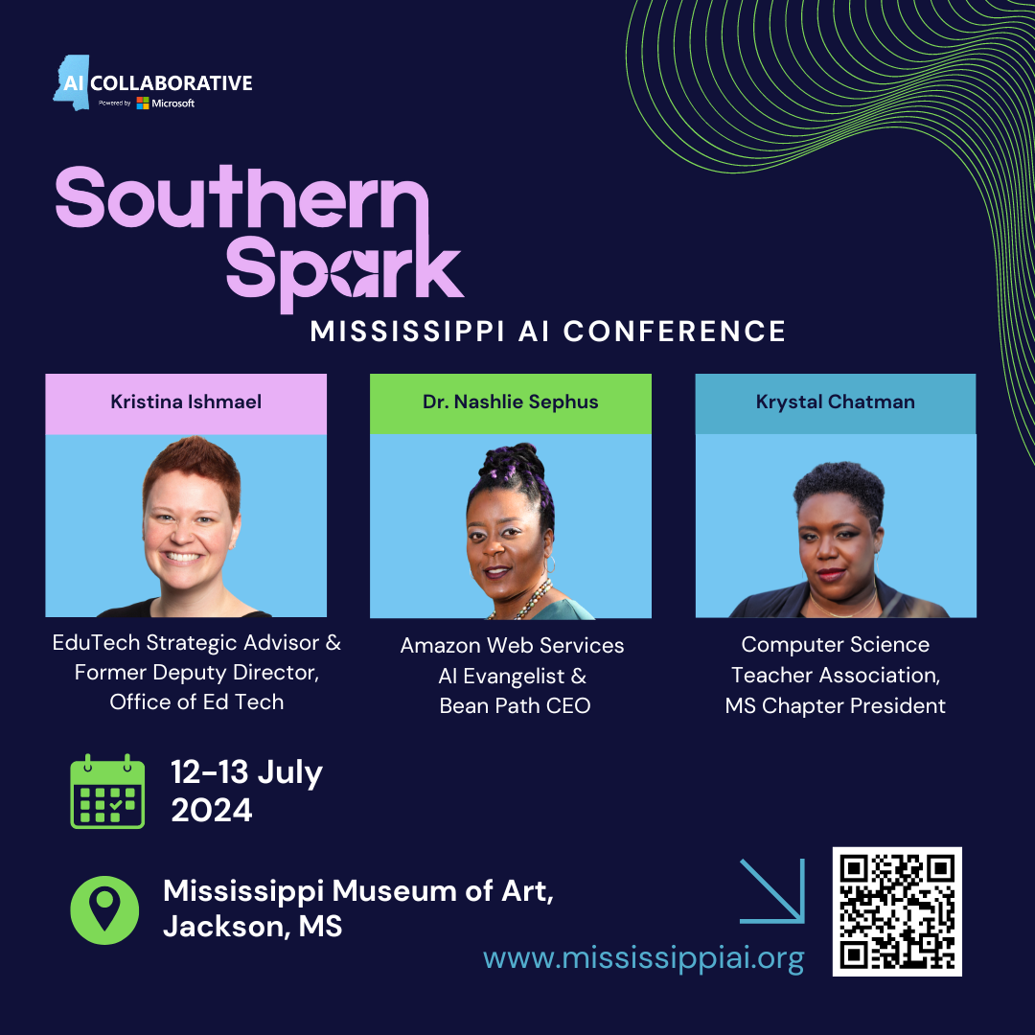

* **Sharpen your skills:** Learn from the best and refine your AI expertise.
* **Fuel your passion:** Discover new ways to leverage AI in your learning environment.
* **Collaborate:** Network with a vibrant community driving the future of AI.
* **Spark a revolution:** Be part of the movement shaping the South's AI landscape.

**Keynote Speakers: Kristina Ishmael, Dr. Nashlie Sephus, and Krystal Chatman**

We are currently accepting proposals for presentations at the conference. The conference will feature three tracks: community, education, and business. A full call for proposals is attached and more information can be found on our website: [southernsparkcon.com](http://southernsparkcon.com)

Please share this with anyone you feel may be interested in this conference and this call for proposals. **Early bird registration will be available on April 15, 2024**.

In addition, there are sponsorship opportunities available in addition to exhibitor opportunities. Email [team@southernsparkcon.com](mailto:team@southernsparkcon.com) to discuss those opportunities.

