|  |
| --- |
| S.T.E.M., LEAVES, & TREES  Mississippi Arbor Day Celebration  *MDWFP's Mississippi Museum of Natural Science*  Friday, February 9, 2024  9 a.m. – 12 p.m. |

Join us for an exciting day learning all about Mississippi trees!

STEM Activities: Leaf ID, Log Dissection, Guided Tree Hikes, Wood Magic, and more!

Special Interactive Themed Exhibits: Soil Tunnel, Wood in Art

Tour the museum's permanent exhibits and hike the trails Explore the new LeFleur’s Bluff Playground!

ADMISSION:

Included with museum admission or MMNS Foundation Membership. Museum admission is: Adults $8, Youth (3-18) $6, Children under the age of 3 are FREE, Senior Citizens (60+) $7.

School Groups (i.e. more than 10 students) can qualify for a group rate.

FOR RESERVATIONS and Group Rate Info: Contact [Yolanda.hawkins@mmns.ms.gov](mailto:Yolanda.hawkins@mmns.ms.gov).

ADDITIONAL INFORMATION: Contact [nicole.smith@mmns.ms.gov](mailto:nicole.smith@mmns.ms.gov).

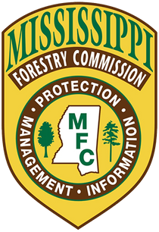

https://bit.ly/mnreservation