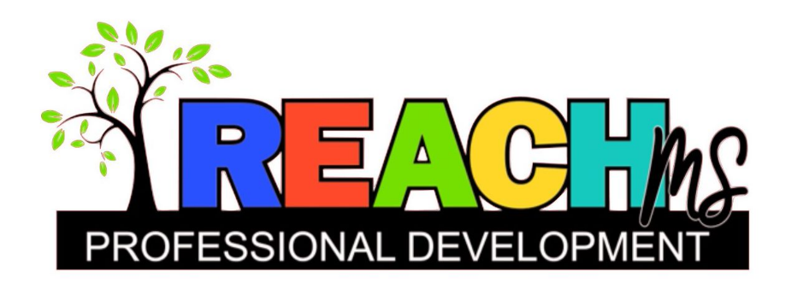

**2023 Early Childhood Priority Group CoP**

Calling all early childhood teachers! Do you need strategies for learning centers? Are the logistics for running learning centers not as smooth as you would like? Are you struggling to determine what content to facilitate during learning centers? What about facilitation – do you need recommendations for that? Is behavior and poor use of social emotional skills at learning centers wearing you down? Are you having difficulty finding time to provide academic support or intervention to specific students? If you said yes to any of these questions, we have an opportunity for you. REACH MS will launch a Community of Practice (CoP) on learning centers for early childhood staff this Fall. This EC Learning Center CoP will target high quality classroom practices (Tier 1) and also provide strategies for supports and interventions (Tiers 2 and 3) during learning centers.

**Click** [**here**](https://usmuw.co1.qualtrics.com/jfe/form/SV_0GU6a0ush2KRDuK) **to register!**

Meeting Day: 2nd Monday of every month September 2023-May 2024

9/11, 10/9, 11/13, 12/11, 1/8, 2/12, 3/11, 4/8, 5/13

Meeting Time: 3:30-4:30

Meeting Place: on Zoom

*Contact Hours will be available upon request.

For questions or more information about this opportunity, email Brittany Herrington at [brittany.herrington@usm.edu.](mailto:brittany.herrington@usm.edu)