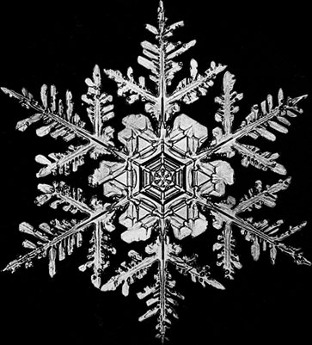

## S.T.E.M. with Snowflakes

**Friday, December 2, 2022   
  
Time: 9 a.m. – 12:00 p.m.**

MDWFP's Mississippi Museum of Natural Science

Experiment with instant snow, create snowflake symmetry with paper snowflakes, explore the fascinating properties of dry ice, and hear the wonderful story of "Snowflake Bentley" - the naturalist and photographer who first captured snowflakes on film. These and other hand-on stations, led by museum educators are part of our holiday S.T.E.M. fun.

$8.00 for adults, $6.00 for children ages 3 and up. Children under 3 are FREE.

Museum Foundation members are FREE. Group Rates available.

To make reservations contact: Yolanda.hawkins@mmns.ms.gov

