Register today at www.mapie.org!

Having trouble finding qualified employees?
Join us for a roundtable discussion on workforce development!

Pine Belt Partners in Education Summit
Thursday, December 6
11 a.m. to 2 p.m.
Hattiesburg High School
301 North Hutchinson Avenue – Hattiesburg, Mississippi
Who should attend:

- Hattiesburg-area employers
- Career and technical education directors
- Superintendents
- Community college workforce development coordinators

Pine Belt Partners in Education Summit will provide an overview of career and technical education programs and highlight the role that school-business partnerships play in creating better opportunities and brighter futures for Mississippi students. Attendees also will tour Hattiesburg High CTE programs and get an up-close look at how they’re preparing the workforce of tomorrow.

The Summit is free of charge with lunch provided.
Registration is required! Please register online by
Tuesday, Nov. 27 at www.mapie.org.

For more information, contact MAPE: mspartnersined@gmail.com, 601-837-1080

Presented by

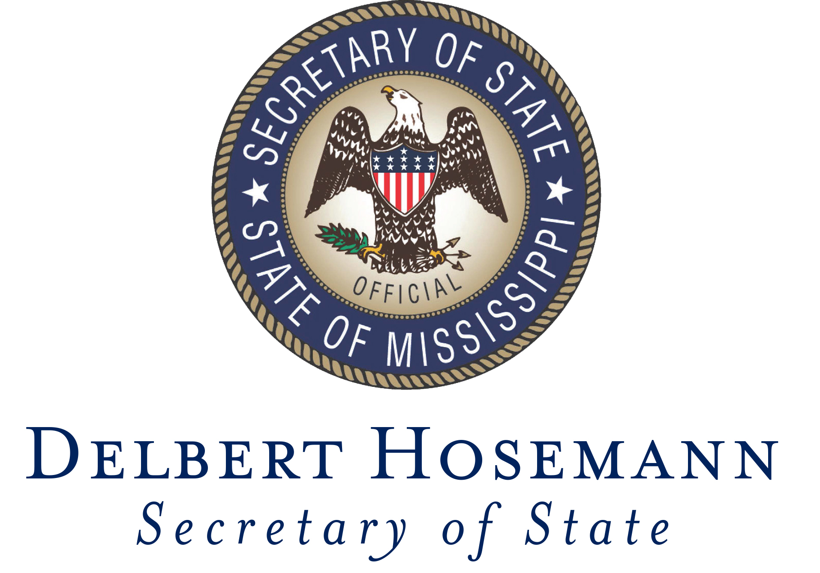

Mississippi Association of Partners in Education and Mississippi Secretary of State’s Office

Corporate Sponsor

