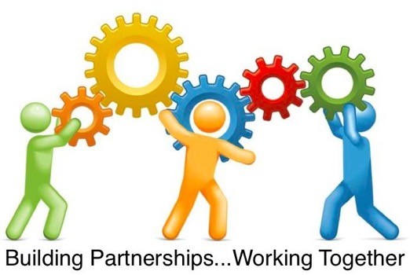

**October 18 – 19, 2018**

**Mississippi’s 10th Annual Special Education Conference**

**For Parents and Professionals**

**The 2018 Building Partnerships…. Working Together Conference will be educational, enlightening and informative for parents, special education professionals and advocates! The conference is also a great networking and relationship building opportunity for those interested in improving outcomes for students with disabilities in Mississippi.**

**KEYNOTE SPEAKER: Rick Daynes**

**Motivational Speaker and Author**

**“Habits of Shiny Happy Parents”**

**(includes strategies and tools every parent needs to be happy and successful)**

**Topics covered during the conference will include:**

* An Overview of the Six Core Principles of IDEA
* Introduction to Social and Emotional Competencies
* Complaining Versus Complaints: Using the Law Without a Lawyer to Help Your Child
* Facilitating Evidence-Based Practice for Students with ASD: A Classroom Observation Tool
* Providing Engaging Experience for Parents; Parental Collaboration and Involvement
* Bringing the Standards Home: Activities for Your Children and Families
* Legal Issues in Special Education
* Not YOURS or MINE……but OURS!!!
* Structuring the Home Environment for Children with Limited Communication/Life and Functional Skills
* Partnering with Parents to Improve Children’s Oral Health
* Wraparound: An Evidence-Based Approach to Support Families, Schools and Communities to Work Together When Things Get Tough
* Dyslexia and Self-Esteem
* Impacting Educational Outcomes through AAC
* A Check for Understanding / Assessing Student Comprehension
* Project Start: Assistive Technology Services

For registration and information on this free event, please visit:

<http://nmec.msresaservices.com/all-workshops/categories-mde/categories-mde-special-education>

Location: Jackson Convention Complex, 105 East Pascagoula Street, Jackson, MS 39201