Page 1
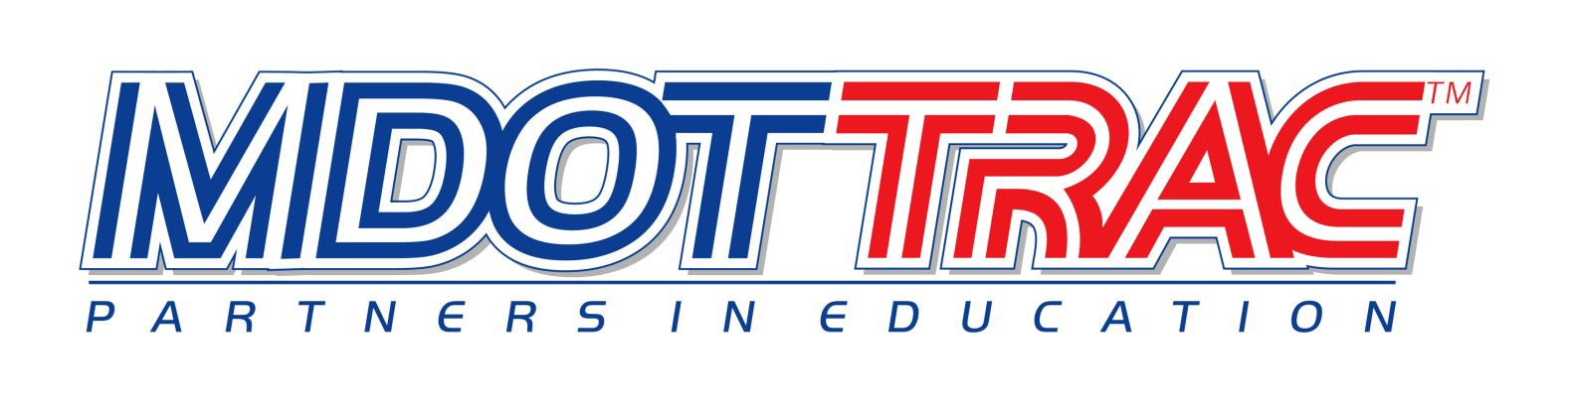
STEM Bridge Builder and Magnetic Levitation Teacher Training Application
The Transportation and Civil Engineering (TRAC) program introduces students to a wide variety of STEM career opportunities in the field of engineering and teaches students how to apply math and science concepts. This hands-on workshop will offer training to Mississippi teachers in Grades 7-12 on the Bridge Builder and Magnetic Levitation Modules. Julia Smith and Billy Carroll will conduct the trainings. The morning session will introduce the Bridge Building Module and guidelines for the MDOT Bridge Challenge. The afternoon session will acquaint participants with the Magnetic Levitation which uses magnetic cars and tracks to teach Newton’s First and Second Laws and other scientific principles. If participants attend both sessions, applications for .5 CEU’s will be offered. Kits will be mailed to teachers whose schools do not have the modules. Please email (with scanned Principal’s signature) this application to carol.killough@yahoo.com or mail both pages to Carol Killough, 645 Hwy. 4 W, Booneville, MS 38829.

By June 29, please apply for the training you would like to attend:

______ July 10
Moss Point Career and Technical Center
3500 Dantzler St.
Moss Point, MS 39563

_____ July 13 ICC – Belden Campus
3200 Adams Farm Rd.
Belden, MS 38826

_____July 20
Madison County District Office
476 Highland Colony Parkway
Ridgeland, MS 39157

Teacher Information (only one name per application)

Name: School Name:

Grade & Subject: Principal:
School District: County:
School Mailing Address:
School Phone
Teacher Email

IMPORTANT: We must have your email address to notify you if you are accepted for the training.

Page 2
Principal’s Agreement
I give my permission for the teacher named above to attend RIDES Training and utilize the program in the classroom. Cancellations must be received in writing to Carol Killough no later than one week prior to the scheduled training date. A $50 administrative fee for full conference registrations will be billed to the participating School Administrator for no shows, cancellations or substitutions received less than one week prior to the scheduled training date.

Principal Signature
MAIL APPLICATION TO: Carol Killough, 645 Hwy. 4 W., Booneville, MS 38829 or Email to: Carol.Killough@Yahoo.com

